**Purpose**

The purpose of the game is for 8-12 year olds to be able to control a character around 3 levels and for them to pick up collectibles under a time limit with a few enemies.

**Target audience**

My target audience for this game is going to range between 8 and 12 year olds.

**Client requirements**

The client will require a well-considered plan that will include deadlines to which we wish to meet certain achievements or even the theme of the game and the outcome for players of playing the game. The client will also require an outline of the types of player and the age range, in this case, 8 to 12 year-olds.

**Legal and Ethical considerations**

For game design, law doesn’t particularly cover anything, besides obviously, copyright. But beside that developers need to be very aware of the ethical considerations within the games, such as racism, homophobia, sexism and stereotyping.

The game must not have anything that would be deemed inappropriate for children ranged between 8-12+ such as horror (scary scenes, images etc.), gambling (with real monies) and sexual content. This is mainly because younger children are influenced quite easily and therefore it is much simpler to manipulate them, this is something we don’t want to happen through our game.

**Type of gameplay**

The game involves navigating a character around an area collecting items and avoiding hazards. Collecting items adds to your score, colliding with hazards uses up lives, of which each game character only has a limited number.

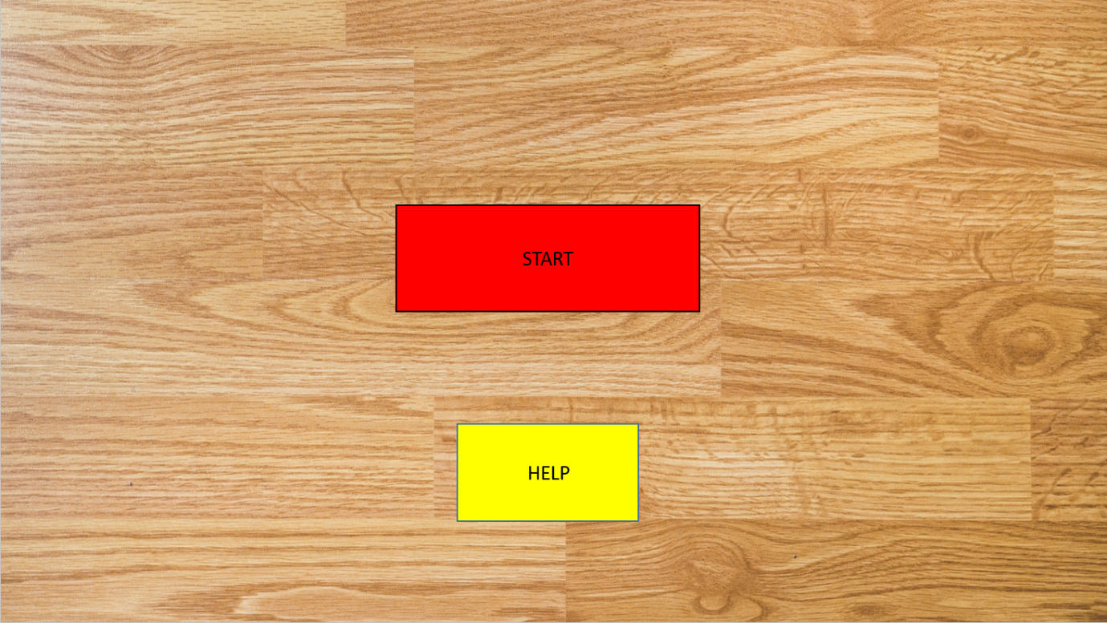

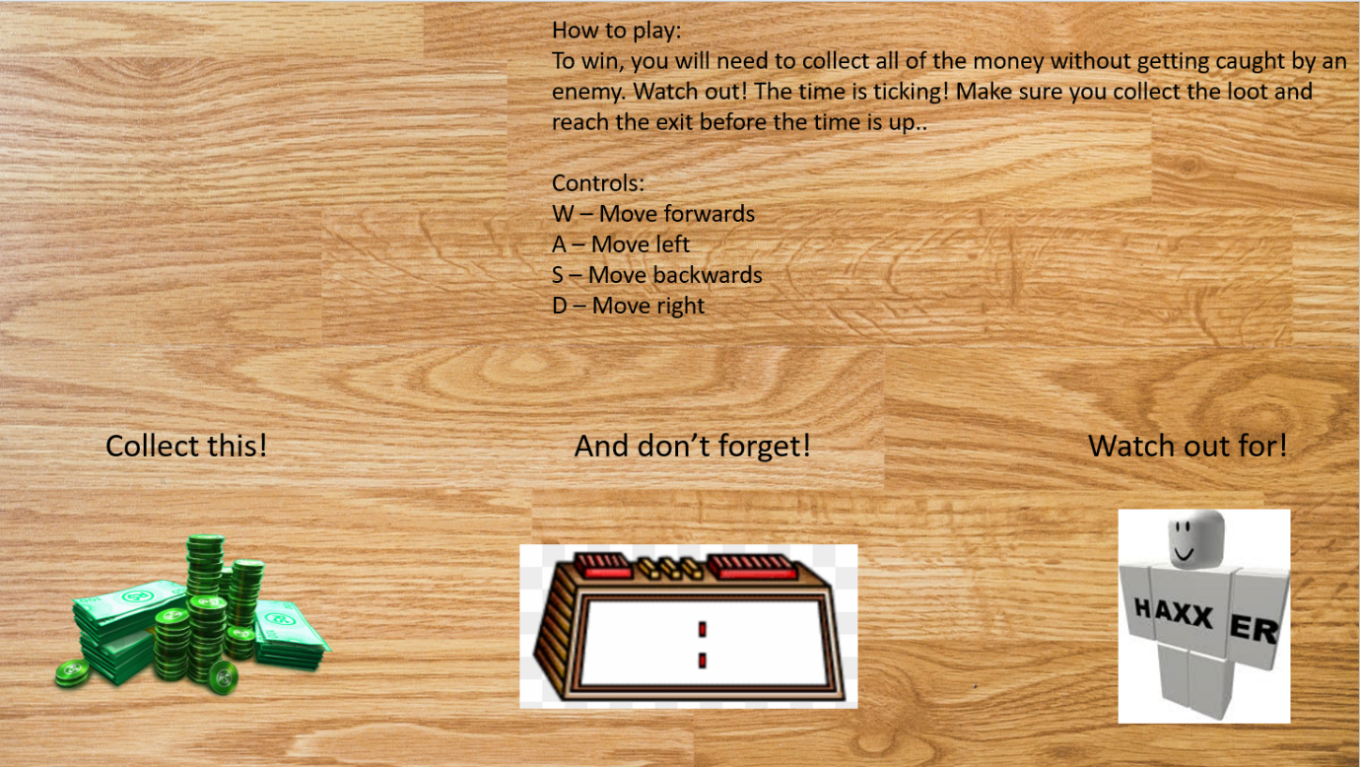

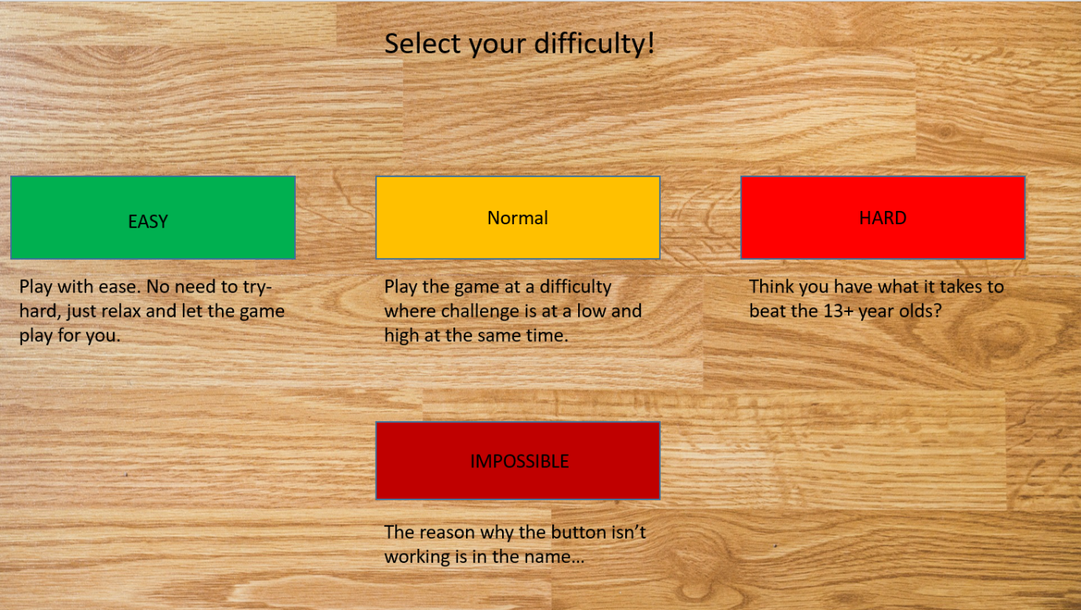

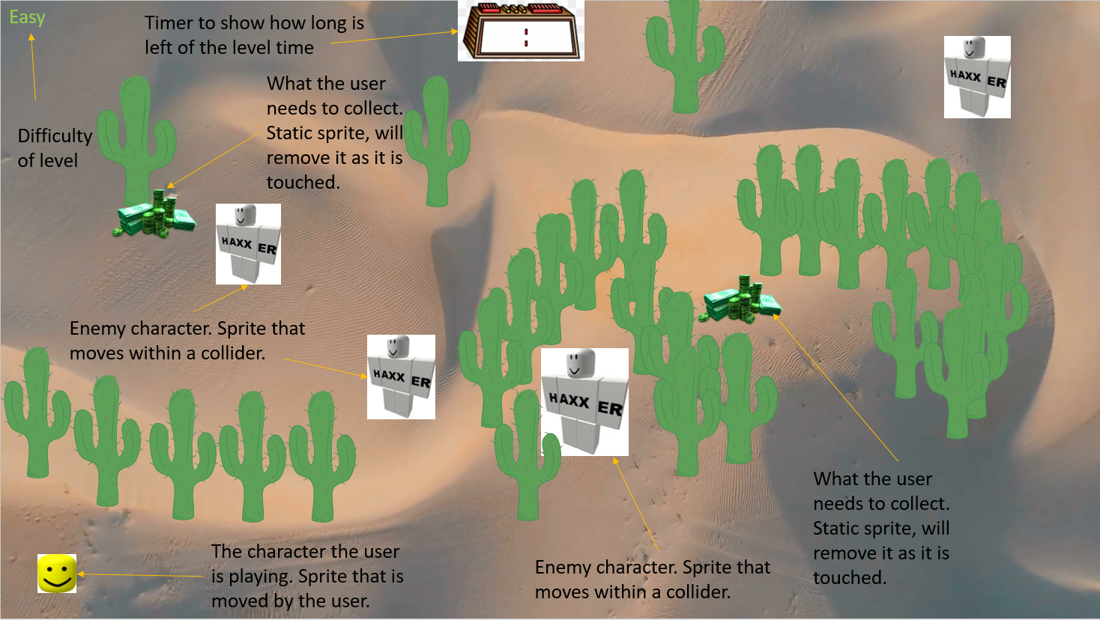

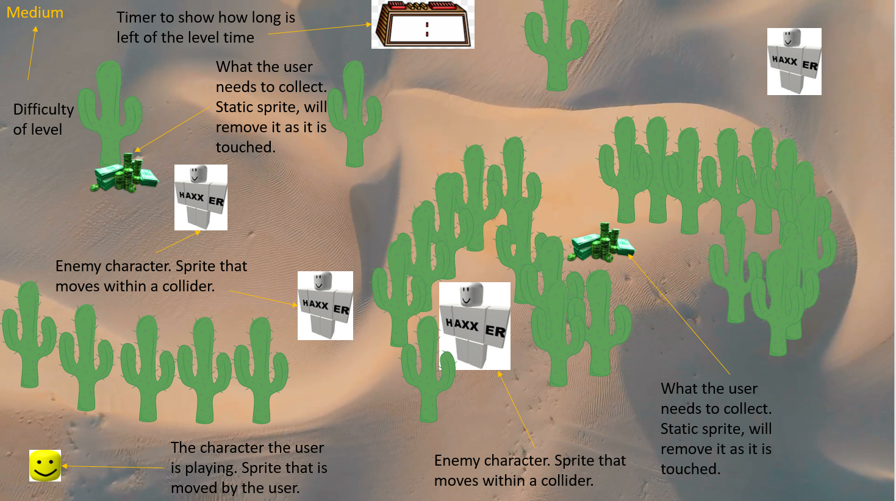

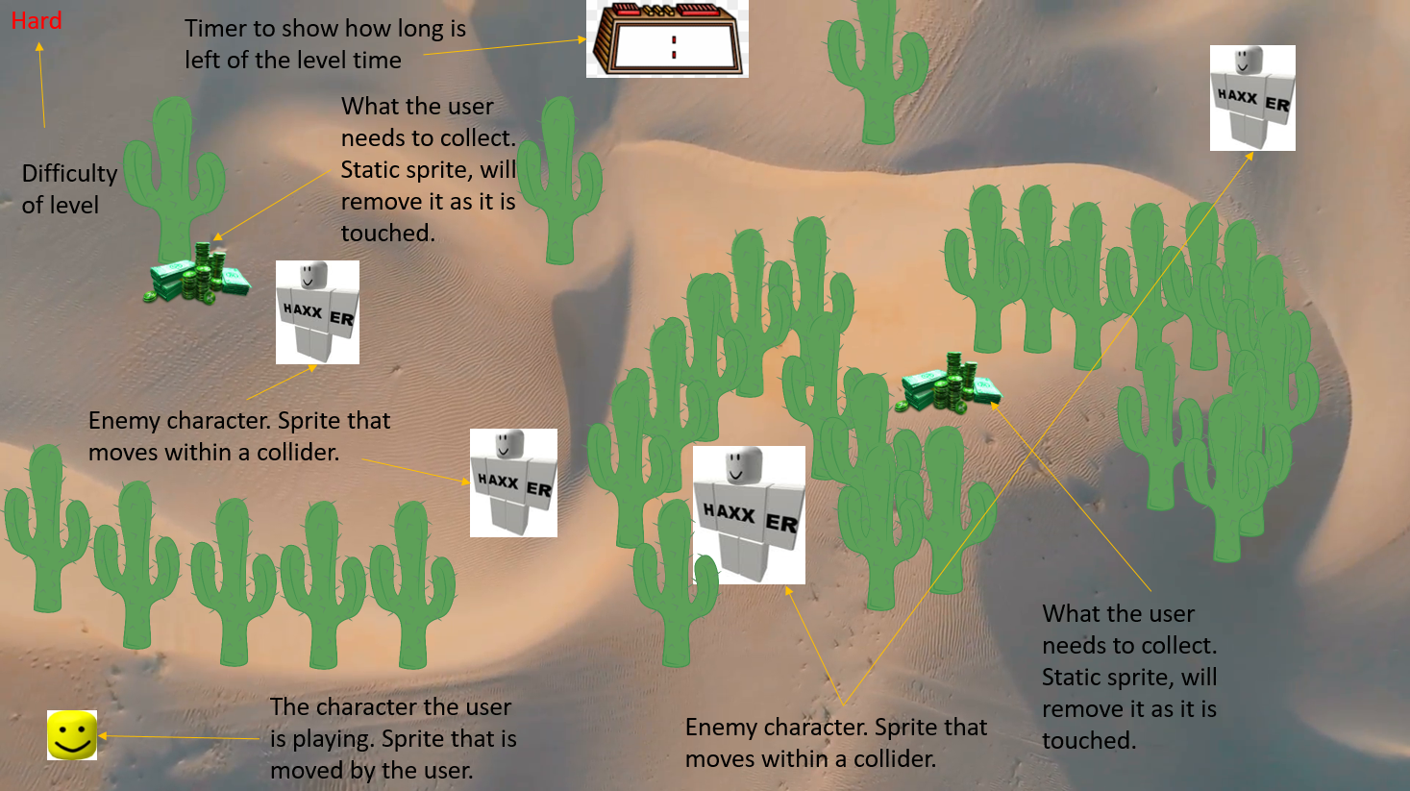

The will be many development choices to be made when designing the game, but most of it is declared by time, if there is plenty of leftover time, MAJOR improvements can be made and even new things can be added, however if there isn’t enough time

**Intended Platform for Delivery**

Platform will be directly PC to prevent the cost to have it on PlayStation or/and Xbox consoles

**Story Boards**

**Algorithm Design**

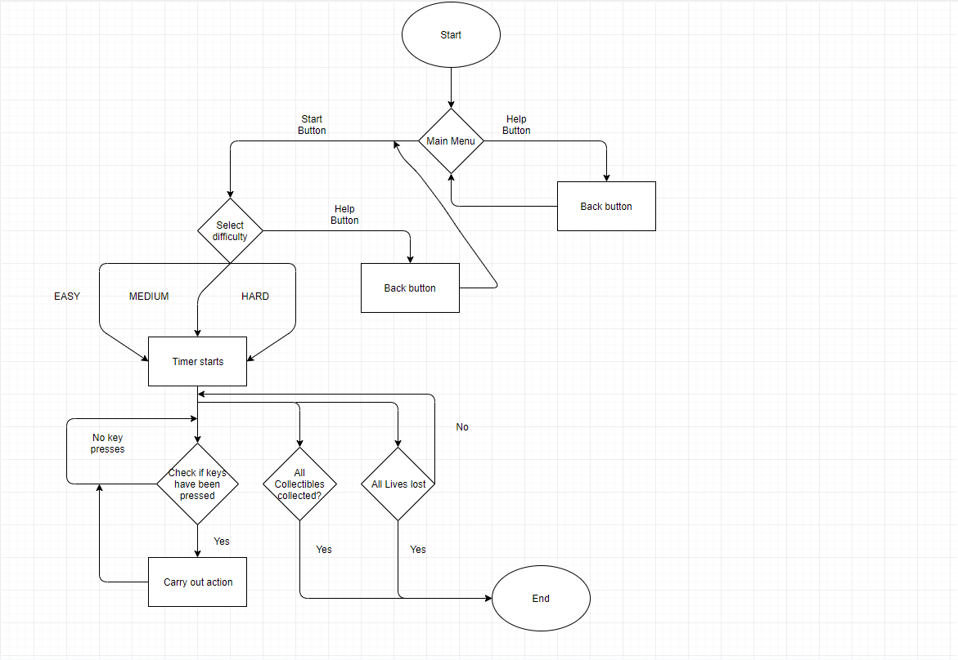

**Data Dictionary**

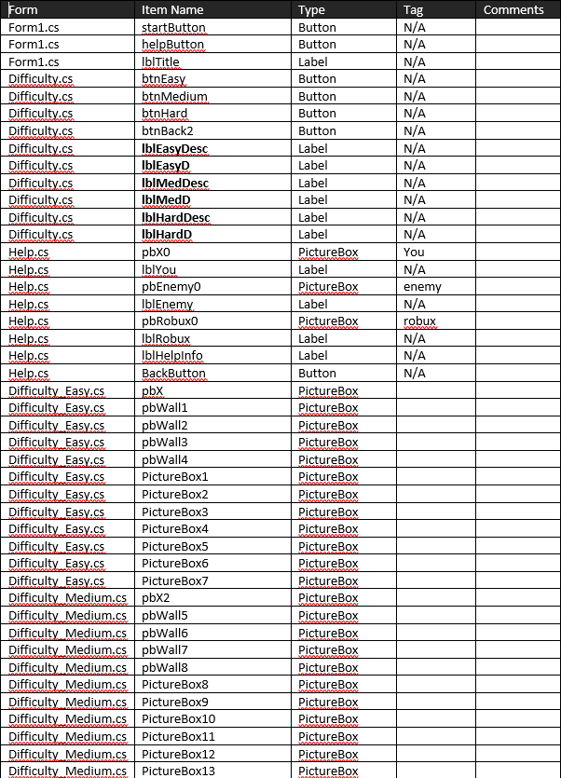

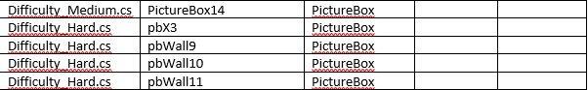

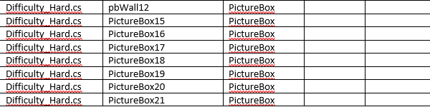

**Storyboards**

The story board will feature designs of what the game is planned to look like, it shows:

The start screen

Difficulty selection

Help screen (instructions)

Level (Easy)

Level (Medium)

Level (Hard)

**Assets**

|  |  |
| --- | --- |
| Graphical | Audio |
| Cactus | Roblox_Death_Sound |
| Desert_Background | Small_Crowd_Applause |
| Digital_Clock | N/A |
| Roblox_Enemy | N/A |
| Roblox_Head_Front | N/A |
| Roblox_Head_Side_Left | N/A |
| Roblox_Head_Side_Right | N/A |
| Robux_Pile | N/A |
| Wooden_Floor | N/A |

**Gameplay features**

The game is set in a desert where the player (Roblox Head) must avoid the enemy character and collect the ‘Robux’ to beat the game. However, there is lots of Cacti acting as walls to make the game slightly harder. The cacti do not provide damage to the player when touched. There are three different levels to play (Difficulty change) in which the time to complete shortens. In the ‘Easy’ mode, the enemies will cover a small area at a slow speed and the user will have infinite time to complete in. In the ‘Medium’ mode, the enemies will cover a larger area at the same speed, this time though, the user will only have 5 minutes to complete the mission. In the ‘Hard’ mode, the user will have only 2 minute to complete the mission and the enemies will cover the same amount of ground at a much quicker speed.

**Hardware and Software**

For this game, the users need to have a very minimum of hardware. They do not need complicatedly powerful CPUs or GPUs; they do not need a high amount or RAM. In terms of software, the game will be an executable program and therefore they will not need Visual Studio to play it.

**Constraints**

My main constraints would be the fact that I do not have an extendable amount of time to create this game, therefore I cannot spend a vast amount of time on developing a very high quality game, although this should not matter too much to the audience who are playing it as they are quite young and things like quality can be beaten by the fun they have when playing the game. However regardless of the limit of time in which I have I must make a functioning game.